## Recap

Privacy has always been considered a very important issue it is the ability of an individual or group to seclude themselves or their information so that they can express themselves selectively. Nowadays, personal data, business data, and many other sensitive data is increasing vastly. Fair information practice and ethics can help us to maintain information privacy. Personal privacy can be physical or informational, it is one of the every individuals right. Physical privacy is to prevent intrusion into one’s physical space or solitude for example we often watch in crime report, face of victim or criminal keep hidden to prevent further harassment. Informational privacy talks about legal right to privacy in collection and sharing of personal or business data. All of us know the incident of wiki leaks or Edward Snowden, how the violation of information privacy can be a matter of even national prestige. In most country informational privacy is maintained by data protection act.

To ensure human dignity and autonomy, privacy is very necessary. It is the right to keep safety form unsanctioned invasion of privacy by any authority. Modern technology somehow contributes in disruption of privacy, authorities with sometime even government support are intervening into public privacy by tracking mobile phone, accessing internet data. We need to ensure our all kind of privacy to keep a safe and comfortable socio-economical life. In many part of the world privacy is considered as a constitutional human rights. In Europe, article 8 of the European Convention on Human Rights guarantees the right to respect for private and family life, one's home and correspondence. Finnish fundamental law (PL 10 §) also say about data protection what secure personal data privacy & process and use personal data.

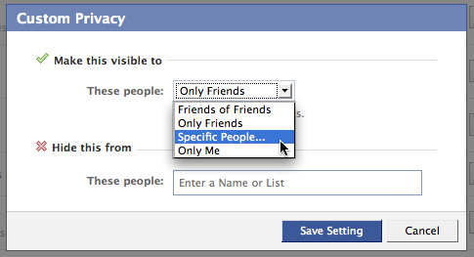 Technological privacy is the privacy of human to reveal or conceal information regarding him according his wish from different technological media ( mostly internet). Different e-commerce site try to advertise their product through email, hackers try to get info of personal & financial data all this are forcing us to be strict on online privacy.

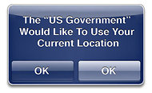

Fig: iPhone and Facebook Privacy.

Therefore all reputed online service provider Facebook, Google, Apple provide privacy option to user so that user is aware which data are being collected for him or to which environment he is exposed. In Finland it is mention to people when he is under surveillance cameras .

## Problem

Full of theory part, little bit real life example would have been interesting to read. Due to weakness of privacy what we are losing some statistical data regarding that could have been nice. Technological privacy is a part of privacy, broad picture of technological privacy was expected from a technology related course.

## Perception

As an educated online user we know how important the privacy is. Any time bank account, email, facebook id can be hacked if we don't maintain proper privacy. Privacy in Nordic countries really in a very high level. Finland could be the role model in terms of privacy to other.

## Deepening

Maintaining privacy on internet is a crucial thing, lot of researchers have been conducted to gather new knowledge about online privacy and follow that. Experts suggest that 1 first of all to tweak social media privacy settings to protect social and personal data. By block third-party cookies we can switch of tracking on our internet surfing records, blocking third-party flash content is also needed as flash has its own cookies. Avoiding signing in any website by other social media's credential ( specially facebook's) is wise, what prevent tracking on data, this type of signing has phishing risk too. Using firewall and secure wireless connect ensure protection and privacy of inbound and outbound network traffic. Browsers has reminding option to make our life easy but it is a weak point from privacy perspective, all kind of username / password reminder should be unchecked. In case of sensitive website browsing ( online bank) using "private browsing window" is better. Logging off the workstation while we are not using it or locking while we are temporary out of it is very good practice. Beside online physically we also need to keep information privacy by controlling unauthorized access of our paper, electronic gadgets on the desk. A "Clean desk policy" can be very effective in this. Beside all this we need to increase level of our ethics not to interfere other persons private issue specially cyber data what is very vulnerable. Instead of monitoring workers internet browsing history software can be installed to block unwanted time consuming sites during working time.

In response of need there are some acts what entitle the authority to gain some data 2 for example

* Children’s Online Privacy Protection Act (COPPA) - gives parents control over their kids cyber activity.
* Health Insurance Portability and Accountability Act (HIPPA) -for patients healthcare-related data.
* Electronic Communications Privacy Act (ECPA) - Government restrictions on electronic data.
* Video Privacy Protection Act - prevents wrongful disclosure of an individual.

# Reference:

1. http://www.lavasoft.com/mylavasoft/company/blog/maintaining-your-privacy-on-the-internet

2. http://searchcio.techtarget.com/definition/data-privacy-information-privacy

Khandker, Syed Ibrahim

WISE